Assignment three: 40 points

1. a. What is the liver fluke’s effect on ants?

2. How do the effects of the liver fluke on ants compare with the information on effects of *Toxoplasma gondii* on humans presented in previous guides? Hint: Make table.

3. (9 points) a. Allowing for 2 new young per generation, fill in the table. The s is missing from the box for sexuals on the website. 4 pts.

|  |  |  |
| --- | --- | --- |
| No of generations | Asexuals | Sexuals |
| 2 |  |  |
| 10 |  |  |
| 50 |  |  |
| 100 |  |  |

b. Allowing for 4 new young per generation, fill in the table

|  |  |  |
| --- | --- | --- |
| No of generations | Asexuals | Sexuals |
| 2 |  |  |
| 10 |  |  |
| 50 |  |  |
| 100 |  |  |

c. Which group wins in both situations, asexual or sexual? Why? 5 pts.

4. a. What advantage did sexual breeding worms possess and how did the laboratory manipulations demonstrate this advantage?

b. What advantage was possessed by sexual breeding topminnows and how did the field manipulations demonstrate this advantage?

Question 5. 10 points.

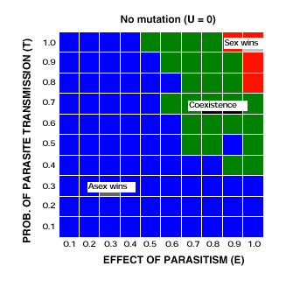

a. Choose the correct alternative. Modeling predicts that sexual reproduction wins only under conditions of ______________(low or high) probability of parasite transmission and ____________ (low or high) effect of the parasite on the biology of the host.

b. If you circled the correct response you predict a world, where most populations of a species are infected by at least one parasite and the probability of catching the parasite is high. Explain. (Hint: Summarize the graph)

6. Hamilton and Zuk’s paper.

6. a. What is the hypothesis being tested?

b. How did the authors test their hypothesis?

c. Briefly summarize their results.

7. a. What is the definition of cospeciation and how do you show it by examining the evolutionary histories (phylogeny) of the species involved. 9 points

Below is an actual tree showing the phylogenies of some gopher hosts and the lice that they carry.

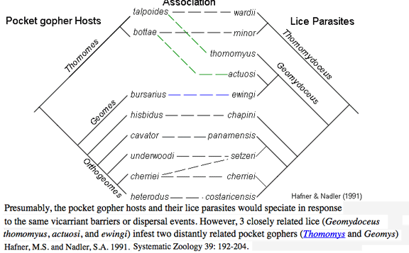

b. Does it show co-speciation between gophers and lice? Defend your answer

c. Why do the authors imply that three species of lice have evolved later than others and “jumped” to some species of gophers?

8. 12 points Turn in b and c for homework.

a. Define

Virulence

Vertical transmission

Horizontal (lateral) transmission

b. Which parasites were transmitted vertically and which laterally or horizontally?

c. Where there any differences in their effects on their host related to their mode of transmission? Defend your answer

Question nine: Tests understanding of material presented in paper of question eight and guide.

9. True or False: Correct false statements.

a. Lateral or horizontal transfer favors low virulence.

b. For any one parasite, hosts harboring different life stages endure the same intensity of virulence.

c. Sexually transmitted parasites tend to be less virulent than parasites not transferred in this fashion.